We are very excited in
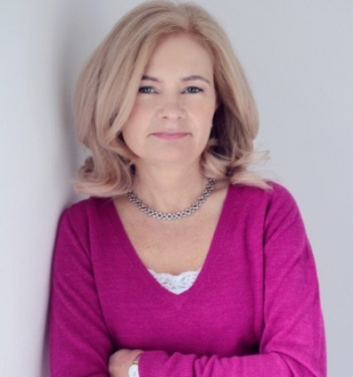
Coláiste Nano Nagle to invite
Judi Curtin
Award Winning Author 2017
To meet JCSP students of 1st and 2nd Year with their Parents/Guardians
11th December 2017
11am-1pm

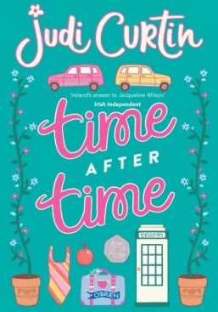
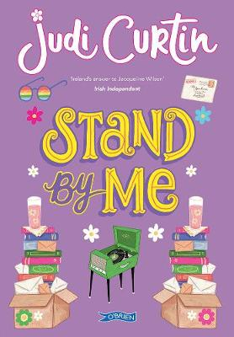
Your daughter has been busy reading these two books written by Judi and we would like to celebrate it with a book signing and talk from the Author with refreshments.

Contact Triona HSCL 085 1573302 for more details

