Our Lady of Lourdes
Local Education Committee

Are hosting a
Christmas Healthy Eating Themed
Cookery
Demonstration
Coláiste Nano Nagle
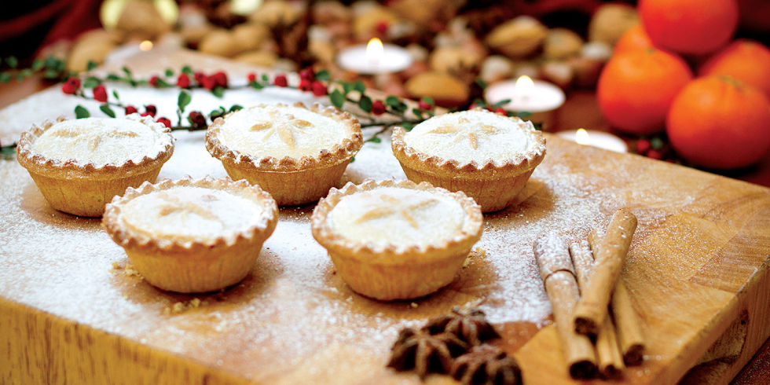
Tuesday 12th December 2017

10am -12pm
To book your place, contact:
Siobhan McKenna 085 7290048
Triona Murray 085 1573302
(Transport will be available from Our Lady of Lourdes Primary School)

